Arduino

Project 2

brian Nannayakkara

2019

Appendix

Projects 2

Project 1 2

Project 1-2 description: 2

Project 3 2

Project 3 description: 2

Project Traffic Light 2

Project Traffic Light description: 2

Time schedule 3

Sources 3

Appendix 3

Wiring1 4

Code1 5

Wiring3 6

Code3 7

Wiring Traffic 8

Code Traffic 9

# Projects

## Project 1

The practice project 1 and 2 are combined

First part is making the circuit and the second part is cording

**Wiring**: Look at the picture on the Appendix wiring1

**Coding**: Look at the picture on the Appendix Code1

### Project 1-2 description:

The 3 LEDs will change flashing moods when pressing the button

## Project 3

### Project 3 description:

This project can recognize the heat and give feedback through LEDs

**Wiring**: Look at the picture on the Appendix wiring3

**Coding**: Look at the picture on the Appendix Code3

## Project Traffic Light

### Project Traffic Light description:

This project is about traffic lights in the road, it’s a simple version of the real life traffic lights. There are 3 LEDs (red, yellow, green) the program starts with red light and then after a while the yellow LED will turn on and then the green LED (only one LED at a time will be on) and after a while the green LED will start blinking, and that means it about to be red again.

**Wiring**: Look at the picture on the Appendix wiring Traffic

**Coding**: Look at the picture on the Appendix Code Traffic

## Project MoveOnBlack

### Project MoveOnBlack description:

This project is about moving a emoro 2560 robot on a black line and make it avoid hitting obstacles.

**Wiring**: Look at the picture on the Appendix wiring MoveOnBlack

**Coding**: Look at the picture on the Appendix Code MoveOnBlack

## Time schedule

## 

28-01-2019: Checked out all the source videos and read about Arduino

29-01-2019: Start making the first project by following instructions in the book

30-01 – 04-02: work with the other projects for get better experience in C++ programing

04-02-2019: made the traffic light project

05-02 – 11-02: work with the EMORO 2560

## Sources

Top 10 Arduino Projects: <https://www.youtube.com/watch?v=eJg3yuAAawA>

Arduino website: <https://www.arduino.cc/en/Tutorial/Blink>

You can learn Arduino in 10 min: <https://www.youtube.com/watch?v=nL34zDTPkcs>

Udemy learn Arduino: <https://www.udemy.com/arduino-workshop-step-by-step-guide/>

Intro til Microcontroller: <https://www.youtube.com/watch?v=dxVh8B4f2eE>

Amazon Robots!: <https://www.youtube.com/watch?v=i0fEiw4ycyY>

EMoRo 2560: <https://www.arduinolibraries.info/libraries/e-mo-ro-2560>

# Appendix

## Wiring1

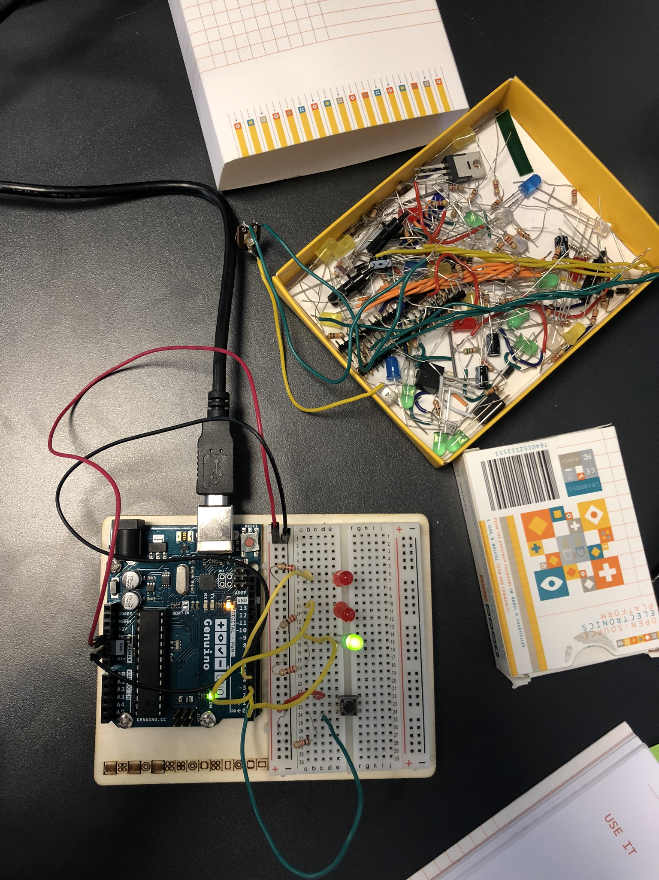

## Code1

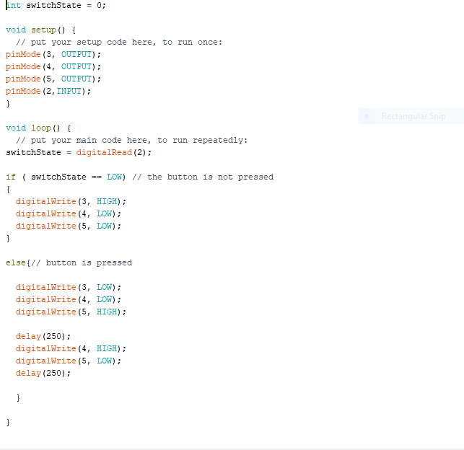

## Wiring3

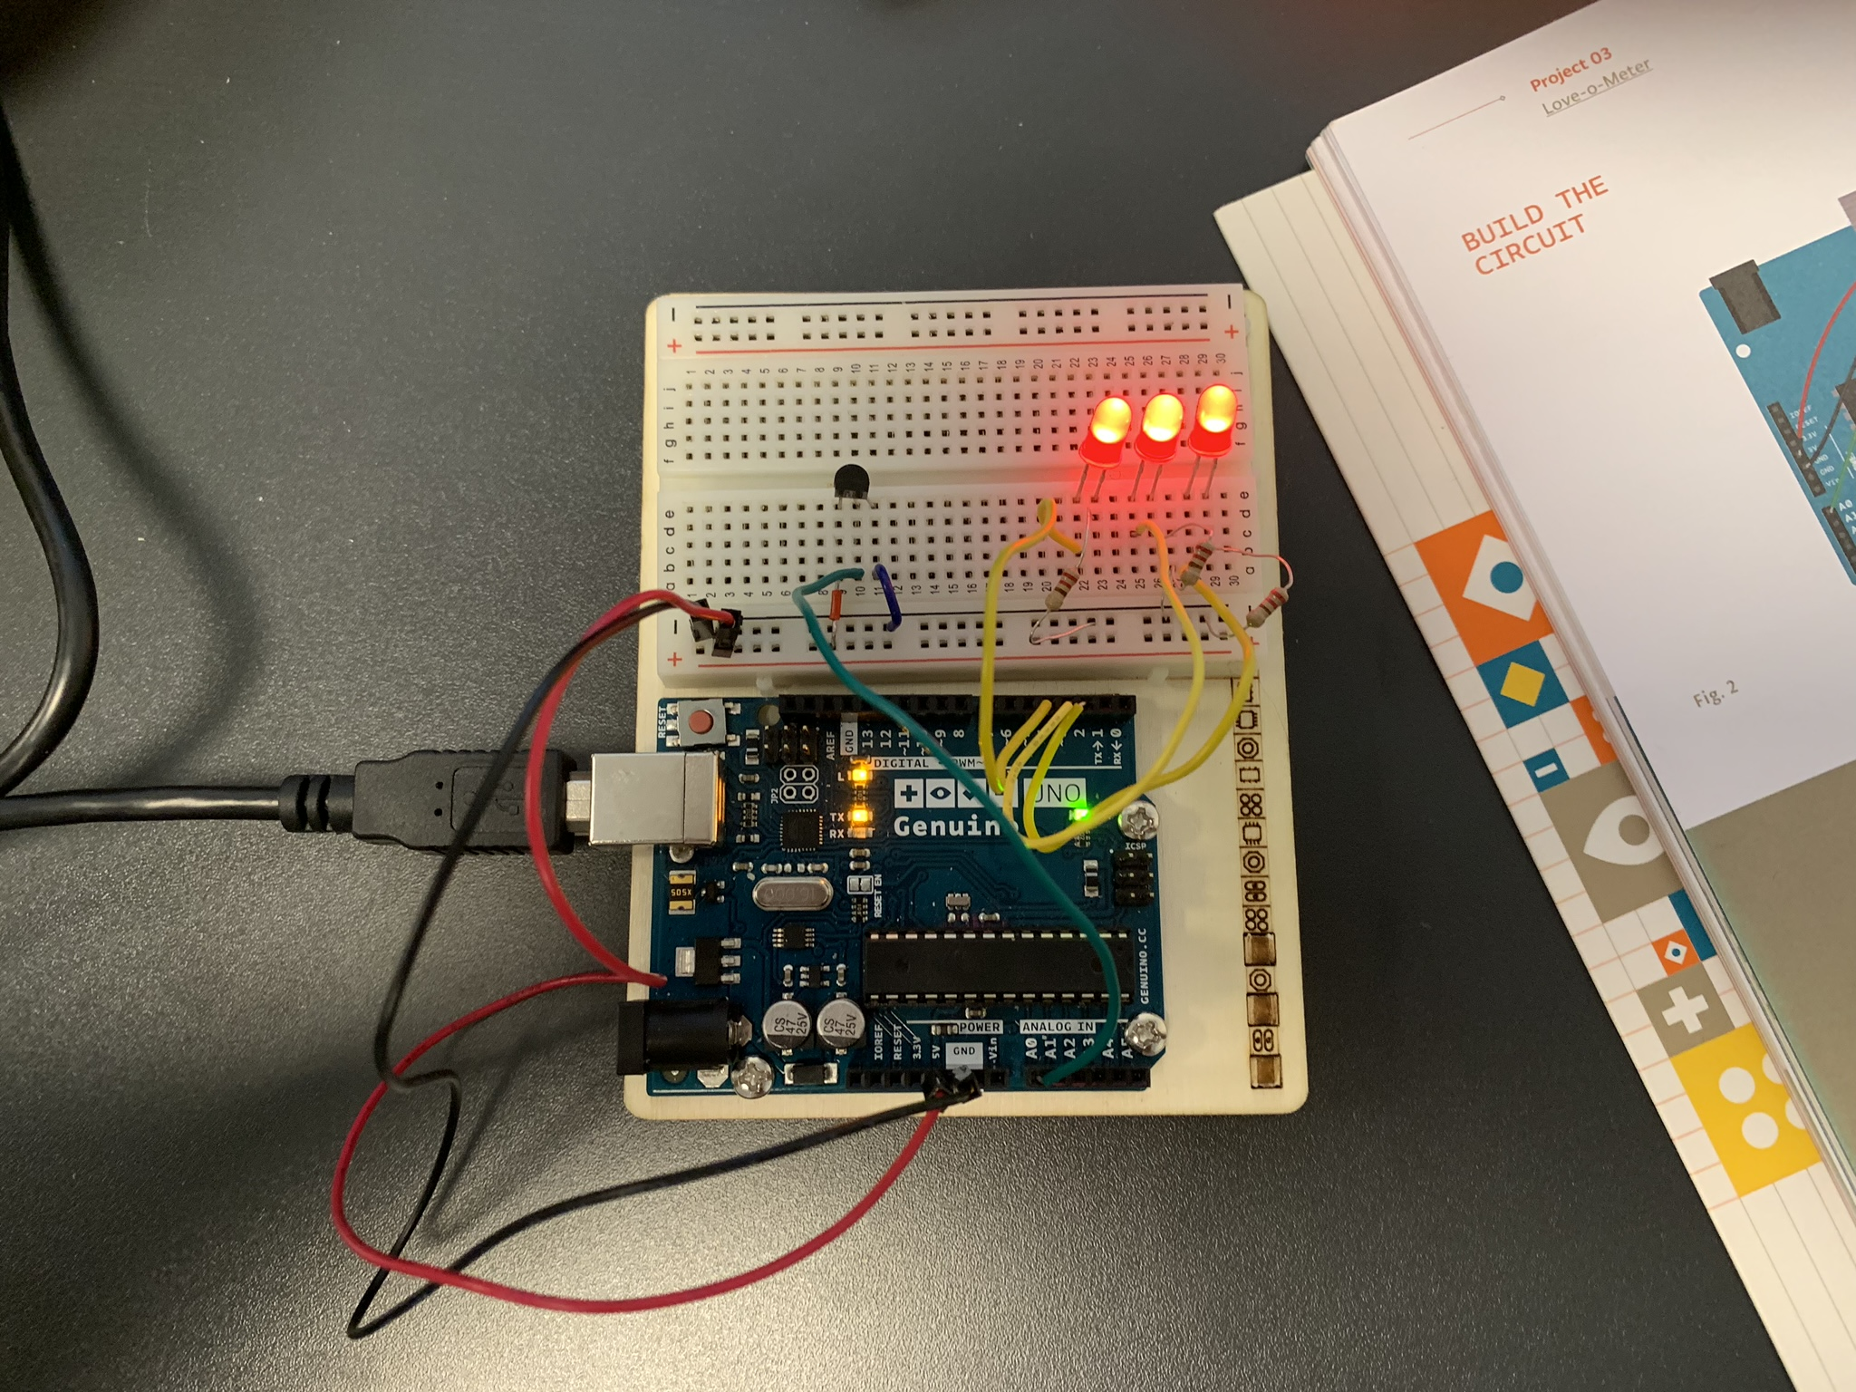

## Code3

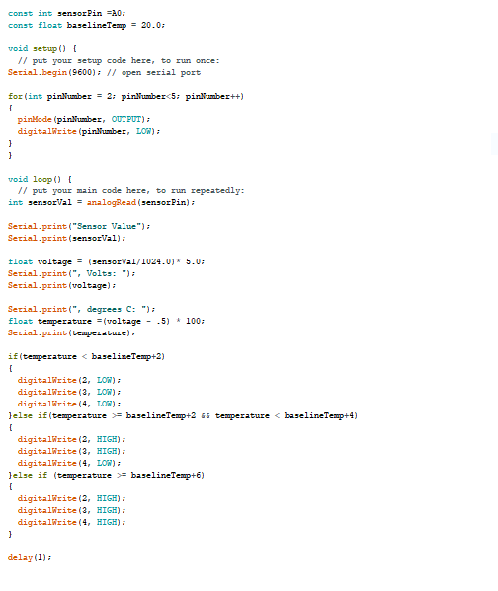

## Wiring Traffic

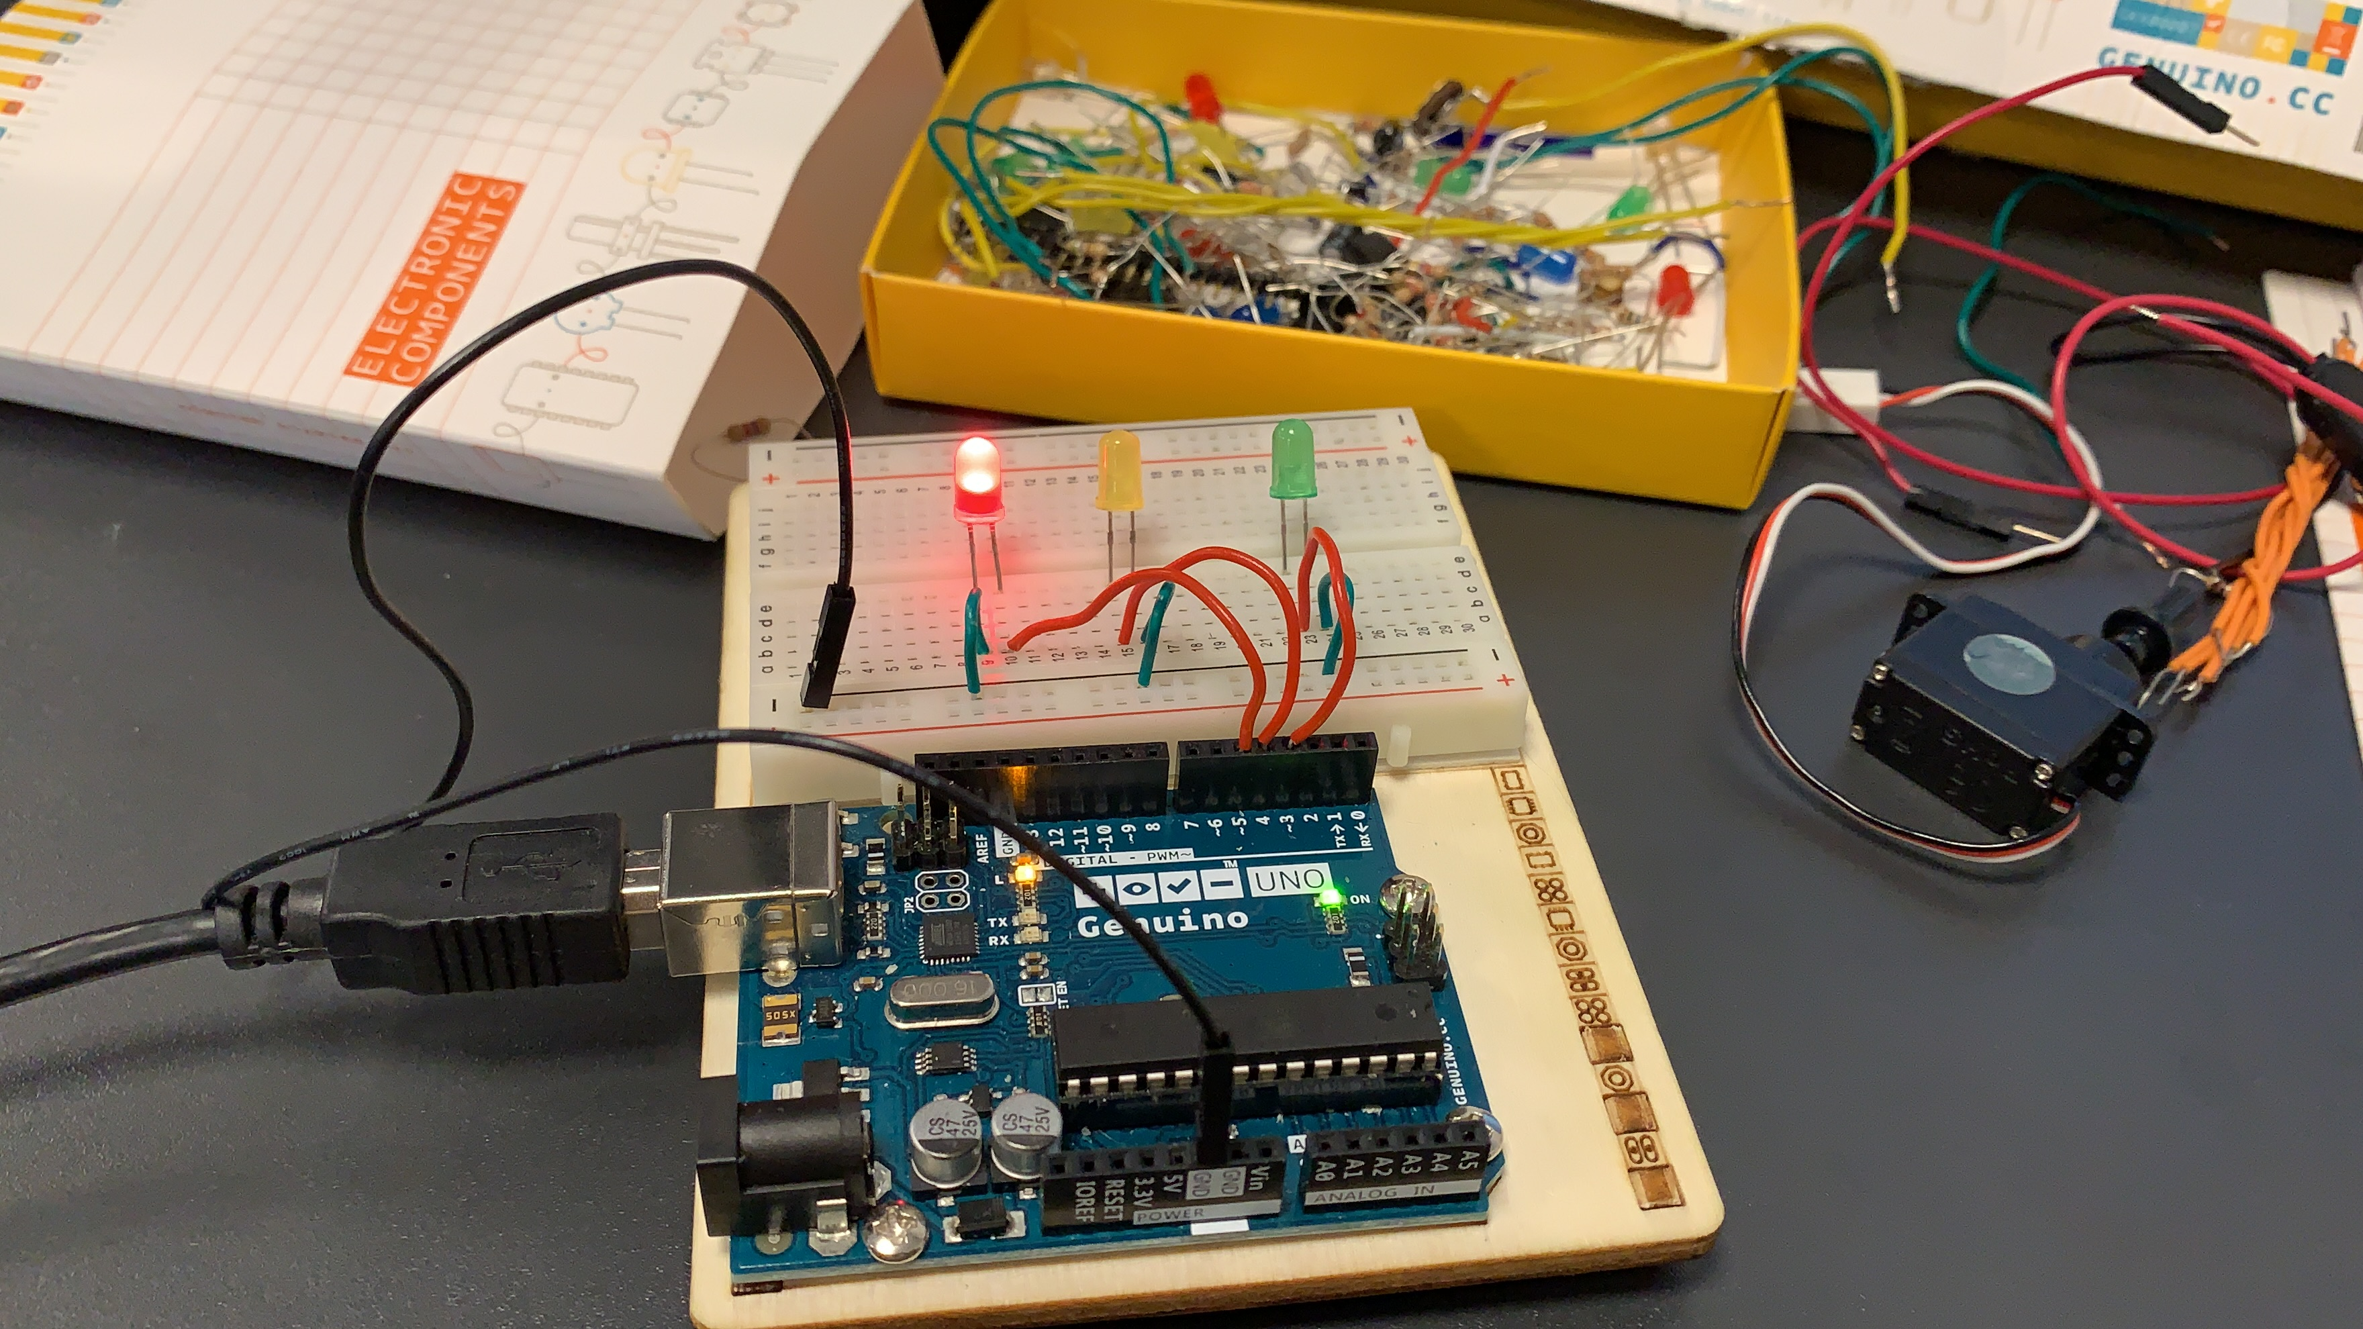

## Code Traffic

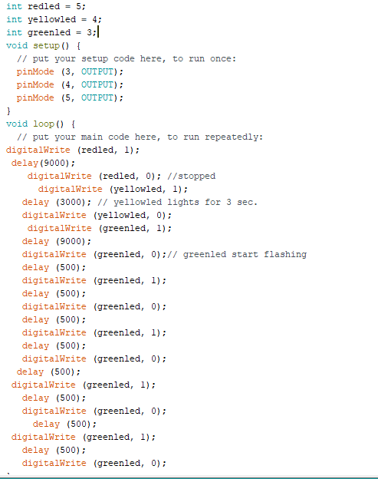

## Wiring MoveOnBlack

I did not have to wire the robot because it was already made but I had to learn the wiring in order to work with the robot

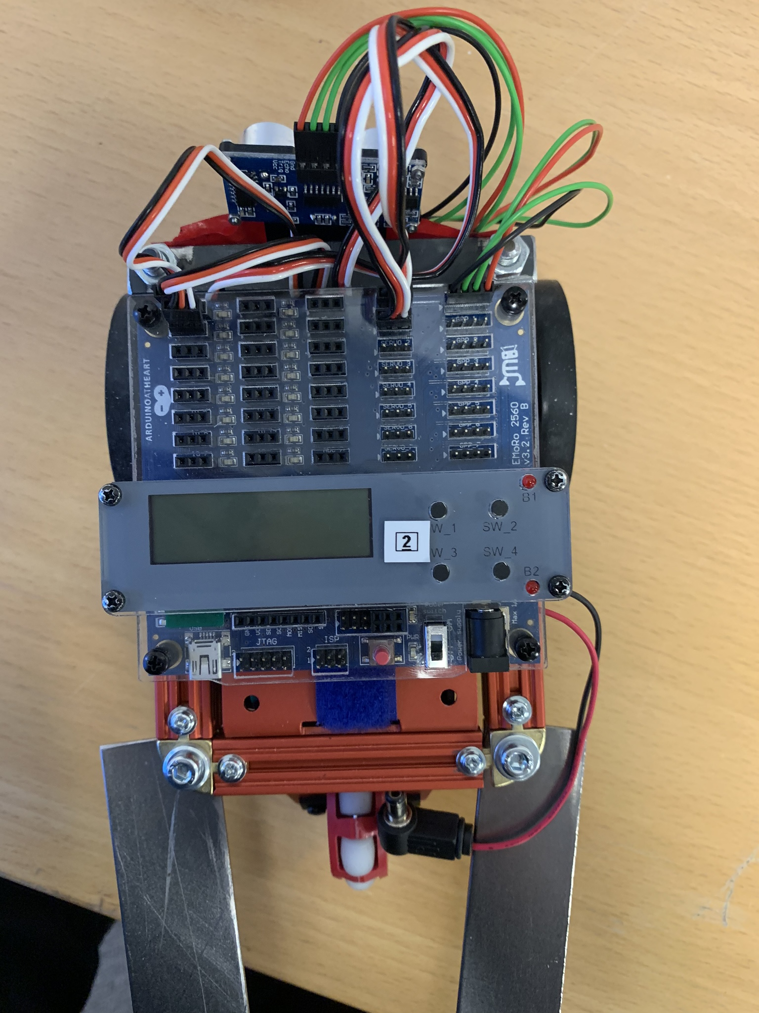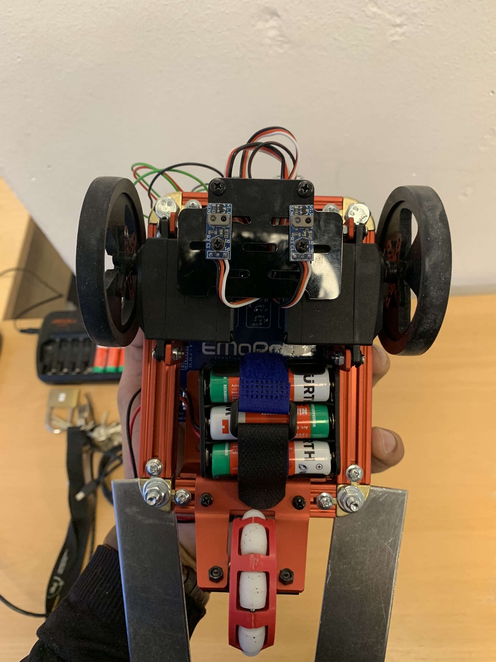

## Code MoveOnBlack

